**NLP - HOMEWORK 1**

I.D: 208722058

**Q1)**

To get all case-insensitive tokens:

tr -sc 'A-Za-z' '\n' < wizard.txt | tr 'A-Z' 'a-z'

To get all case-insensitive types:

tr -sc 'A-Za-z' '\n' < wizard.txt | tr 'A-Z' 'a-z' | sort | uniq

To get all starting words with “ea”:

grep -E '^ea'

And to count all words:

wc -l

**So overall, we get for (A) types:**

tr -sc 'A-Za-z' '\n' < wizard.txt | tr 'A-Z' 'a-z' | sort | uniq | grep -E '^ea' | wc -l

* **8**

**And we get for (B) tokens:**

tr -sc 'A-Za-z' '\n' < wizard.txt | tr 'A-Z' 'a-z' | grep -E '^ea' | wc -l

* **26**

**Q2.1**.1**)**

For $P$ precision and $R$ recall, which are positive numbers in $[0,1]$:

$$F_{1}\overset{?}{≤}\operatorname{avg}\left(P,R\right) \\ \frac{2PR}{P+R}\overset{?}{≤}\frac{P+R}{2} \\ \frac{4PR}{2\left(P+R\right)}\overset{?}{≤}\frac{{\left(P+R\right)}^{2}}{2(P+R)} \\ 4PR\overset{?}{≤}{\left(P+R\right)}^{2} \\ 4PR\overset{?}{≤}P^{2}+2PR+R^{2} \\ 0\overset{?}{\overbrace{≤}}P^{2}\overset{?}{≤}2PR+R^{2} \\ 0≤\underset{always non-negative}{\underbrace{{\left(P-R\right)}^{2}}}$$

**Q2.1**.2**)**

In general, for some arbitrary $β,$ $F_{β}≤\operatorname{avg}\left(P,R\right)$ is no longer true.

For example, when $β=0$:

$$F_{2}\overset{?}{≤}\operatorname{avg}\left(P,R\right) \\ \frac{PR}{0∙P+R}\overset{?}{≤}\frac{P+R}{2} \\ \frac{2PR}{2R}\overset{?}{≤}\frac{\left(P+R\right)R}{2R} \\ 2PR\overset{?}{≤}PR+R^{2} \\ PR\overset{?}{≤}R^{2}$$

And for $P=0.2$ and $R=0.1$ we get:

$$0.2*0.1\overset{?}{≤}{0.1}^{2} \\ 0.02≰0.01$$

**Q2.2)**

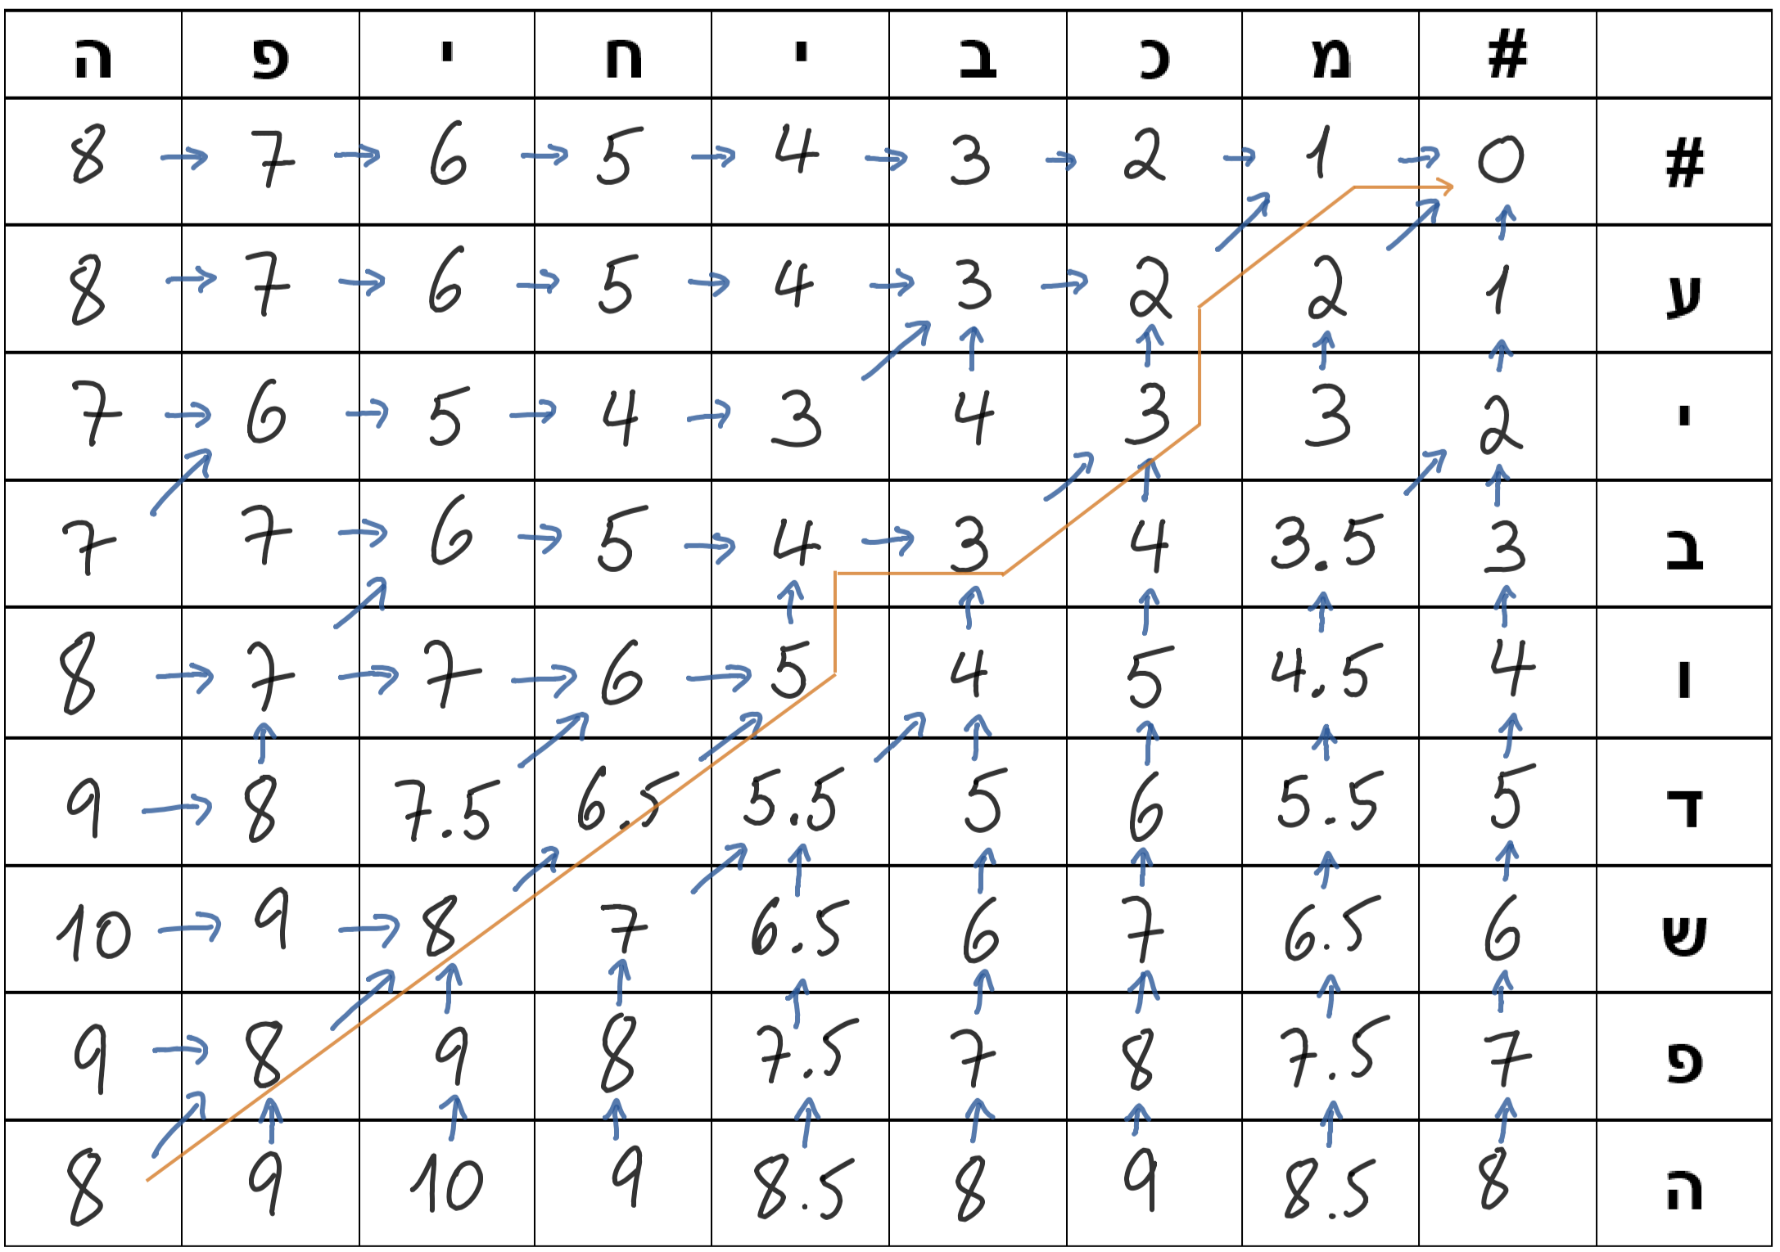

|  |  |  |  |  |  |  |  |  |  |
| --- | --- | --- | --- | --- | --- | --- | --- | --- | --- |
| **ה** | **פ** | **ש** | **ד** | **ו** | $$∅$$ | **ב** | **י** | **ע** | $$∅$$ |
| **ה** | **פ** | **י** | **ח** | $$∅$$ | **י** | **ב** | $$∅$$ | **כ** | **מ** |
| **= (0)** | **= (0)** | **Sub (1.5)** | **Sub (1.5)** | **Del (1)** | **Add (1)** | **= (0)** | **Del (1)** | **Sub (1)** | **Add (1)** |

Overall: $ךוונשטיין\left(עיבודשפה, מכביחיפה\right)=8$

**Q3**.1**)**

For data:

* $d_{1}=$"היתה תקופה כזו שהאושר בא זעם" , $y_{1}=1$
* $d_{2}=$"את עולמי עם שחר, את לי כל היום" , $y_{2}=0$
* $d_{3}=$"עכשיו יש את הזמן במזרחית" , $y_{3}=1$

**The features values are:**

$f_{1}=〈1,1,1,1,1〉$

$f_{2}=〈1,0,3,0,1〉$

$f_{3}=〈0,1,0,1,1〉$

(With 5th parameter as bias)

**Q3**.2**)**

The parameter update function:

$θ^{\left(t+1\right)}=θ^{\left(t\right)}-η∙∇L_{CE}\left(θ^{\left(0\right)}\right)$

$$θ^{\left(0\right)}=〈0,0,0,0,0〉$$

Iteration 1:

$${\hat{y}}^{\left(1\right)}=σ\left({\vec{f}}_{1}∙{\vec{θ}}^{\left(0\right)}\right)=σ\left(0+0+0+0+0\right)=σ\left(0\right)=0.5$$

$η\left(1\right)=0.8$

$$∇L_{CE}\left(θ^{\left(0\right)}\right)=\left({\hat{y}}^{\left(1\right)}-y_{1}\right)∙f_{1}=\left(0.5-1\right)∙〈1,1,1,1,1〉=-0.5∙〈1,1,1,1,1〉=〈-0.5,-0.5,-0.5,-0.5,-0.5〉$$

$$θ^{\left(1\right)}=〈0,0,0,0,0〉-0.8∙〈-0.5,-0.5,-0.5,-0.5,-0.5〉=〈0.4,0.4,0.4,0.4,0.4〉$$

Iteration 2:

$${\hat{y}}^{\left(2\right)}=σ\left({\vec{f}}_{2}∙{\vec{θ}}^{\left(1\right)}\right)=σ\left(〈1,0,3,0,1〉×〈0.4,0.4,0.4,0.4,0.4〉\right)=σ\left(0.4+0+1.2+0+0.4\right)=σ\left(2\right)≈0.88$$

$η\left(2\right)=0.4$

$$∇L_{CE}\left(θ^{\left(1\right)}\right)=\left({\hat{y}}^{\left(2\right)}-y_{2}\right)∙f_{2}=\left(0.88-0\right)∙〈1,1,1,1,1〉=0.88∙〈1,0,3,0,1〉=〈0.88,0,2.64,0,0.88〉$$

$$θ^{\left(2\right)}=〈0.4,0.4,0.4,0.4,0.4〉-0.4∙〈0.88,0,2.64,0,0.88〉=〈0.4,0.4,0.4,0.4,0.4〉-〈0.352,0,1.056,0,0.352〉=〈0.048,0.4,-0.656,0.4,0.048〉$$

Iteration 3:

$${\hat{y}}^{\left(3\right)}=σ\left({\vec{f}}_{3}∙{\vec{θ}}^{\left(2\right)}\right)=σ\left(〈0,1,0,1,1〉×〈0.048,0.4,-0.656,0.4,0.048〉\right)=σ\left(0+0.4+0+0.4+0.048\right)=σ\left(0.848\right)≈0.7$$

$η\left(3\right)=0.27$

$$∇L_{CE}\left(θ^{\left(2\right)}\right)=\left({\hat{y}}^{\left(3\right)}-y_{3}\right)∙f_{3}=\left(0.7-1\right)∙〈1,1,1,1,1〉=-0.3∙〈0,1,0,1,1〉=〈0,-0.3,0,-0.3,-0.3〉$$

$$θ^{\left(3\right)}=〈0.048,0.4,-0.656,0.4,0.048〉-0.27∙〈0,-0.3,0,-0.3,-0.3〉=〈0.048,0.4,-0.656,0.4,0.048〉-〈0, -0.081,0,-0.081,-0.081〉=〈0.048,0.481,-0.656,0.481,0.129〉$$

**Q3**.3**)**

For data:

* $d_{4}=$" אם כבר אז שיירד כאן שלג"

The feature values are:

$f_{4}=〈0,0,1,1,1〉$

(With 5th parameter as bias)

And now for the model:

$$\hat{y}=σ\left({\vec{f}}_{4}∙{\vec{θ}}^{\left(3\right)}\right)=σ\left(〈0,0,1,1,1〉×〈0.048,0.481,-0.656,0.481,0.129〉\right)=σ\left(0+0-0.656+0.481+0.129\right)=σ\left(-0.046\right)≈0.049$$

**Therefore, the model will predict that the data $d_{4}$ is a sentence from a Shlomo Artzi song.**

**Q4)**

In general, I already enjoy the class lectures and material as it is delivered. For me, I find it a bit confusing to have multiple definitions names both in English and in Hebrew and I would prefer that we would stick to a single defining name during the lectures (and preferable in English).